**Autumn Craft Ideas**

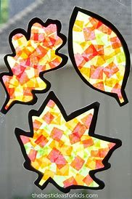

**Autumn Leaf Sun Catchers**

Resources:

Black card

Coloured tissue paper

Glue

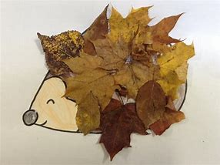

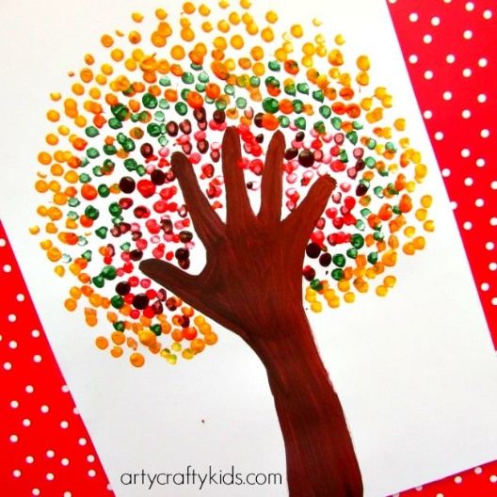

**Handprint Tree**

Resources:

Paper

Paint

**Autumn Leaf Hedgehog**

Resource:

Print out of hedgehog

Leaves

Glue

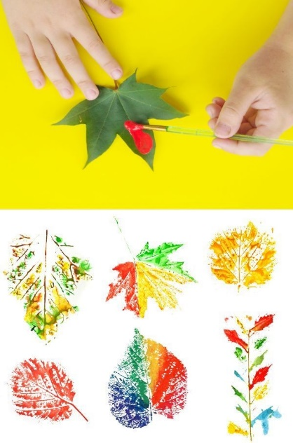

**Fork Stamped Hedgehog**

Resources:

Print out of hedgehog

Paint

Fork

**Leaf Painting**

Resources:

Leaves

Paint

Paper