**Coffee & Chat in association with**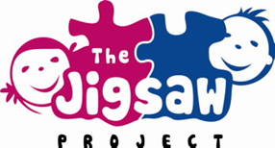

***So why attend?***

***It’s an opportunity to discuss any worries and concerns you might have and also where you can find online safety tips, advice and resources to help children and young people stay safe online.***

***Little Stars is available for this day only!***

To mark ***Safer Internet Day***, Jigsaw will be hosting a coffee & chat gathering on Tuesday, 6th February for parents/carers between 2 – 3pm.

-

Please join us for a tea/coffee, treat and an informal chat about engaging with your children and their digital lives! For further information, please contact Janice (Jigsaw Worker) on 07935518393.

