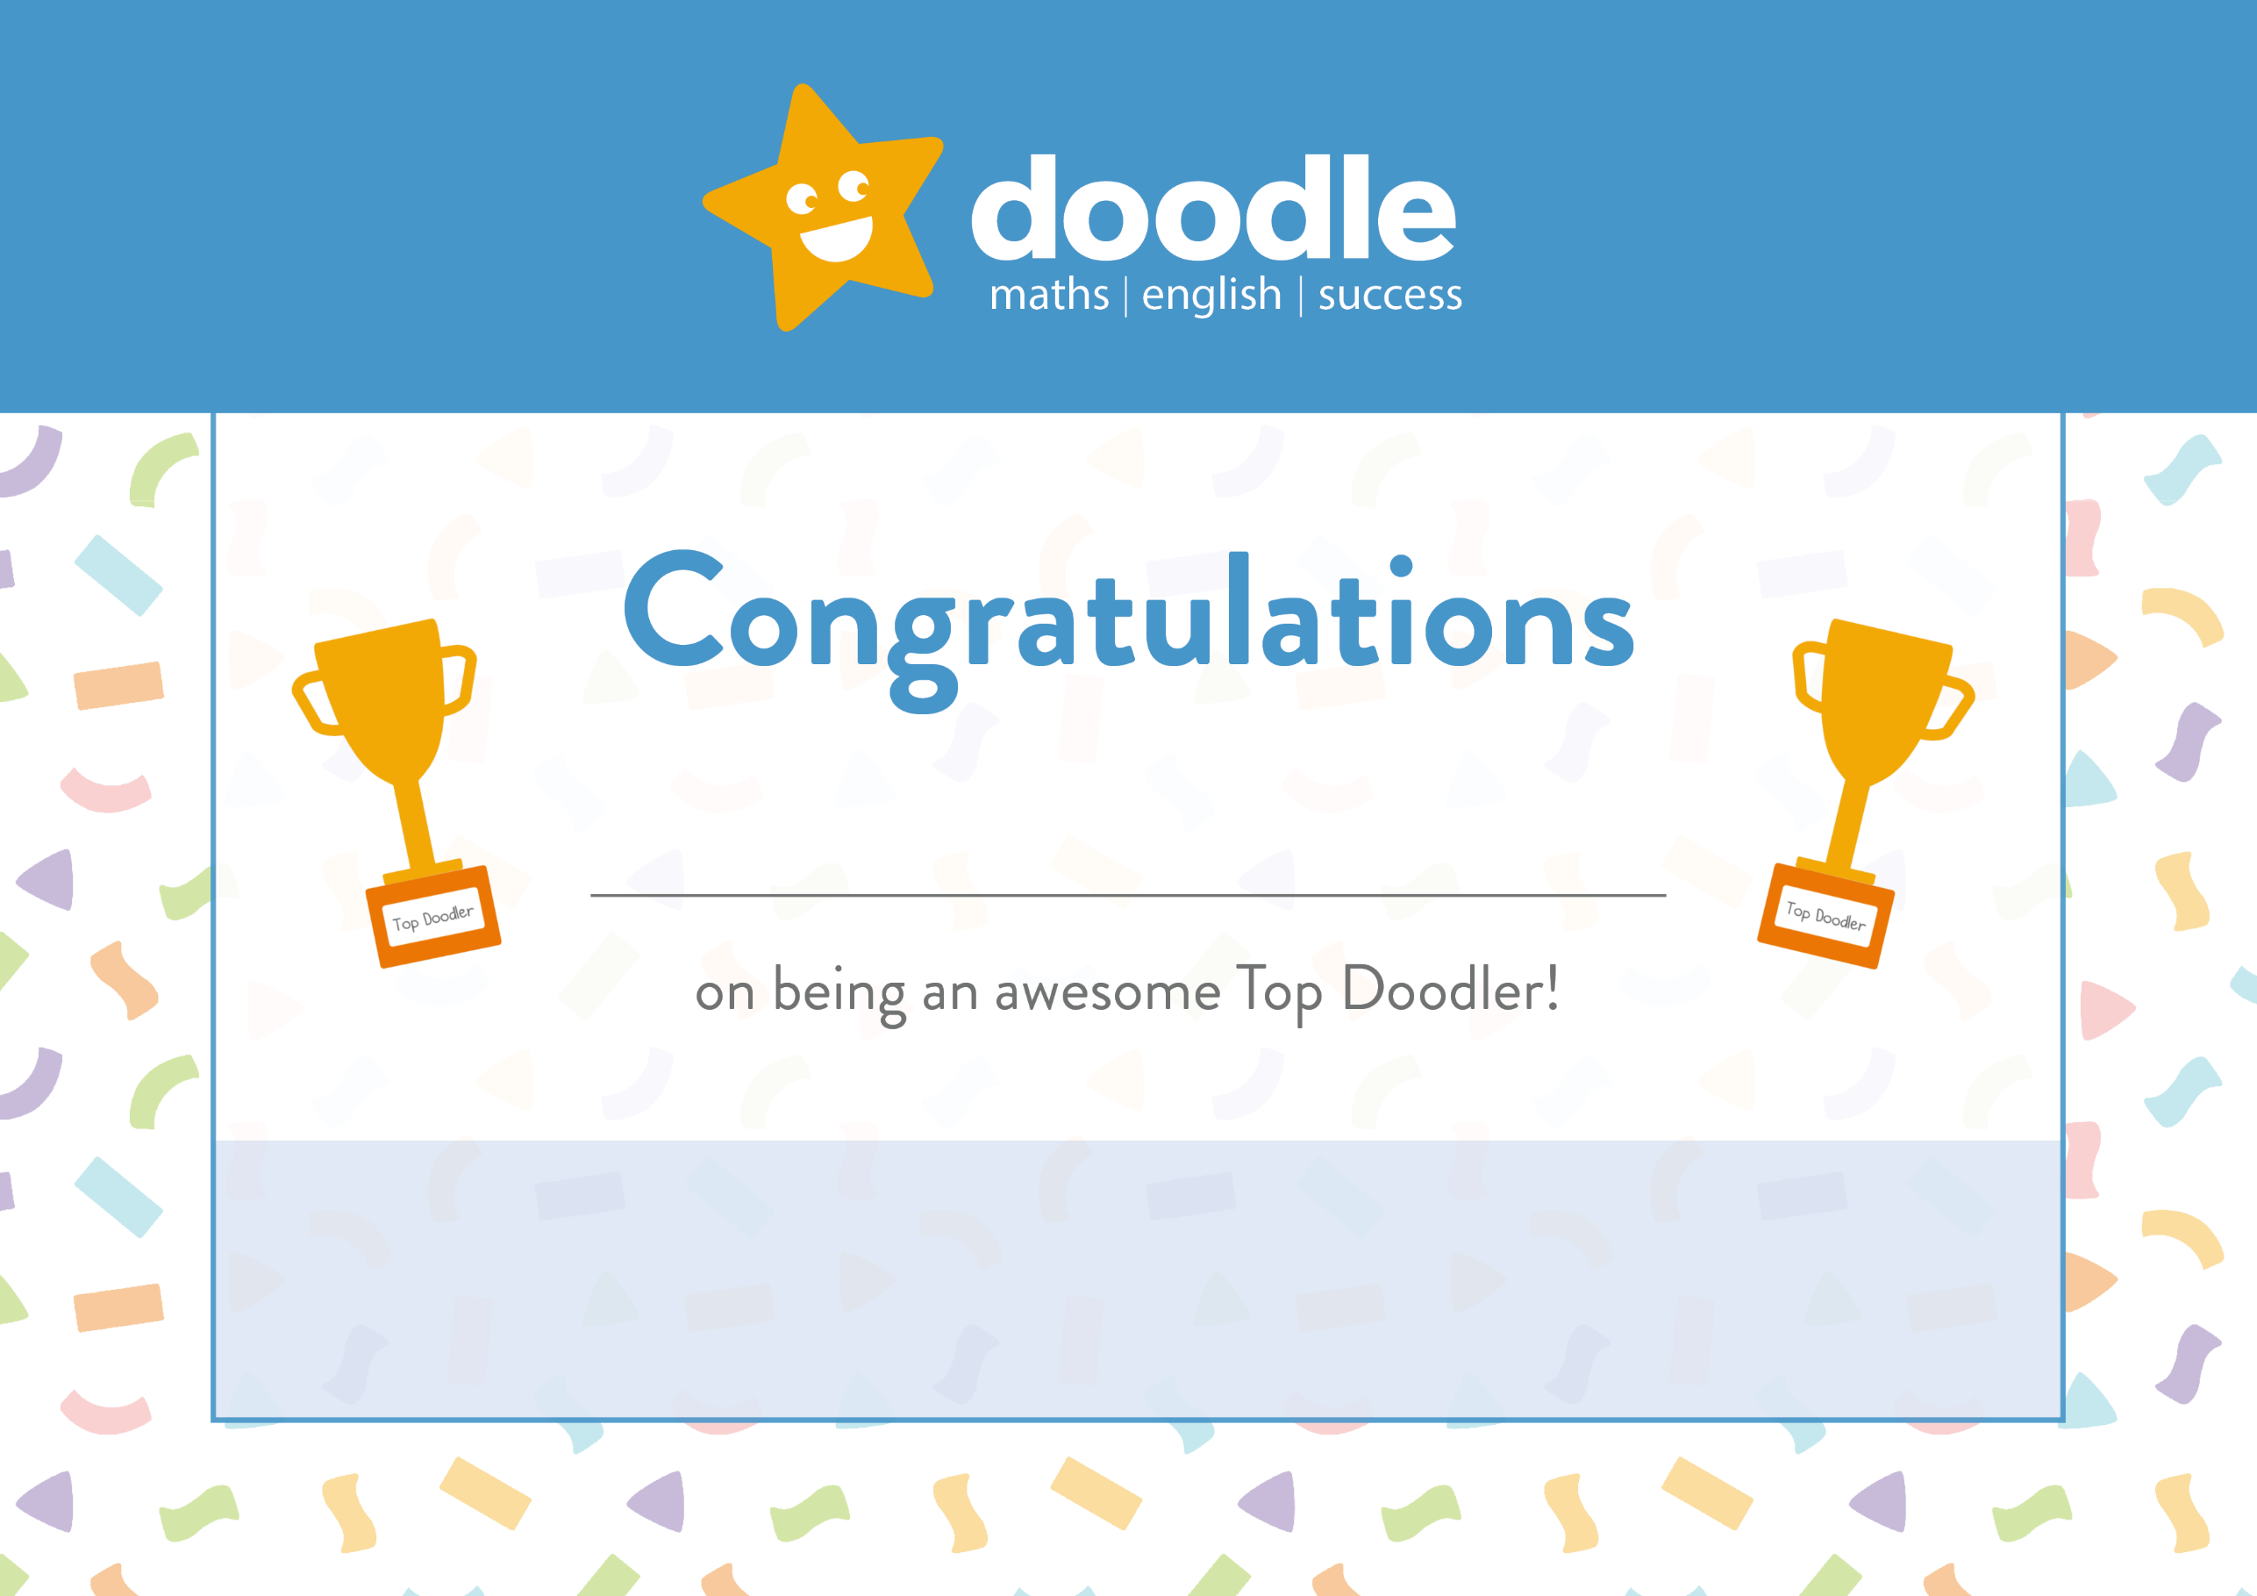
Well done, you are the Top Doodler in P6AM!
24th May 2020
Jamie

