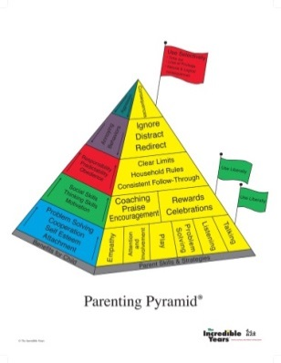[](http://www.google.co.uk/url?sa=i&rct=j&q=&esrc=s&source=images&cd=&cad=rja&uact=8&ved=0ahUKEwiZjceQjZPWAhWCbxQKHTrjADYQjRwIBw&url=http://lifespanstages-meihong.weebly.com/late-childhood.html&psig=AFQjCNGB5Za_PQ6DSQnhaGui9hJTEbpuJQ&ust=1504874647164233)

**The Incredible Years**

**Parenting Programme**

**FREE Course for Parents and Carers Promoting Positive Behaviours for Children 7 – 12 years old**

I liked having somewhere to come for me, I am valued for myself and not just someone’s mum.

**What parent’s say:**

**Coffee & Introduction morning:** Thursday 24th January 2019

9.30 am – 11am

**Programme Starts:** Friday 1st Feb 2019 (12 week course **not** running over school holidays) 10am – 12 noon

**Venue:** The Braid Townhall, Ballymena

**The programme is designed to strengthen parenting skills, build strong relationships, and promote positive behaviour in children.**

**Topics Covered -**

**-** Strengthening children’s social skills and ability to manage difficult feelings

**-** Using Praise and Incentives to Encourage Cooperative Behaviours and Motivate children

**-** Household Rules, Learning Routines, & Effective Limit Setting

**-** Positive Discipline, Calm Down Strategies and Handling Misbehaviour

I liked sharing experiences with the other parents and discussing ideas in a safe, non-judgemental and confidential group.

It’s definitely reduced my ‘mum guilt’

I’ve enjoyed this time for me once a week, the time flew in.

It helped develop my confidence as a parent. Helping me to enjoy being a parent.

My children stick to the rules and boundaries I put in place

I liked having somewhere to come for me, I am valued for myself and not just someone’s mum.

I feel more empowered as I have friends in the group who I know are going through the same things and can

support me.

I rarely need to use time out now with my kids.

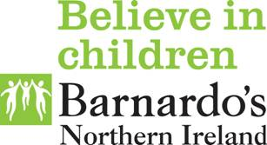**[](http://www.google.co.uk/url?sa=i&rct=j&q=&esrc=s&frm=1&source=images&cd=&cad=rja&uact=8&ved=0ahUKEwjB-Iva2aHLAhVHWxQKHbkKCoQQjRwIBw&url=http://newrytimes.com/2015/06/25/choose-to-protect-yourself-the-new-sexual-health-campaign-from-the-pha/&bvm=bv.115339255,d.d24&psig=AFQjCNFRsaMUYd0AcKxG7kYgkx4oad74sQ&ust=1456997614922412)**

It truly works and I would recommend every parent does it; it honestly makes home and your kids happier.

I have fun with my kids; we spend time together as a family

I now think about my own feelings and reactions. How they would affect my child’s outlook on life.

I feel more empowered as I have friends in the group who I know are going through the same things and can

support me.

It was great to know I’m not alone and that EVERY Child misbehaves, it’s normal. I know how to deal with it now too.

For more information or to sign up please

contact your Jigsaw Family Worker.

**Christine Doherty - 07864800662**

**Email:** [christine.doherty@barnardos.org.uk](mailto:christine.doherty@barnardos.org.uk)

I know and believe now that I’m a good parent.