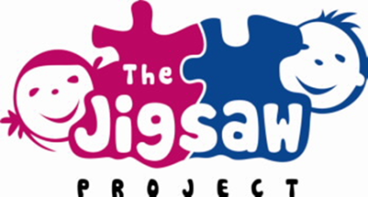
Grandparents Day
The Jigsaw Project and Primary 2 would like to invite all grandparents to join their class for an hour of fun filled activities.
Come join us on Thursday 17th January 2019 at 9.15am – 10.15am.

Tea and coffee will be provided.

We would love to see you all there!

If you are able to attend our ‘Grandparents Day’, please reply with this slip to Mrs Archibald or Miss Crawford by Monday 14th January 2019.

Name of grandparent/s: __________________________
Name of child and class: __________________________

